**Dear Parents,**

With Fall Basketball coming to a conclusion this weekend and Winter starting up, it gives us a bit of an inflection point as a team.  I wanted to take this time and remind everyone of some team rules, participation expectations, etc.

**Team Participation Rule**:  Starting each November, I begin keeping track of attendance at each practice/game.  Each practice/game is considered one event and each player that is there gets one point for attending the event.  We keep a running percentage of attended events.  As long as you maintain a 70% attendance or higher, there are no negative consequences.  Players that drop below 70% risk their playing time being cut entirely until they once again get above 70%.  The week of Christmas, the player with the highest participation % receives a $100 gift card.  All other players above 70% will be entered in a drawing for 2 additional $50 gift cards.  At the end of the season "Senior Night" we award the player with the highest participation for the season as our "Iron Jaguar" and that comes complete with a custom championship belt.  Some might have seen Nyk Lewis or Silas Devonish posing with their belts the last two years.

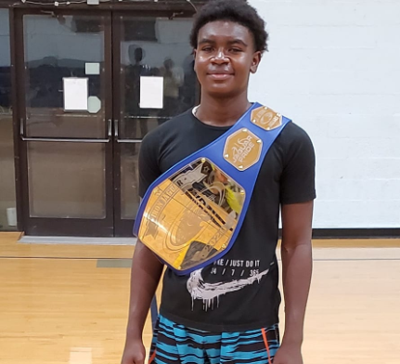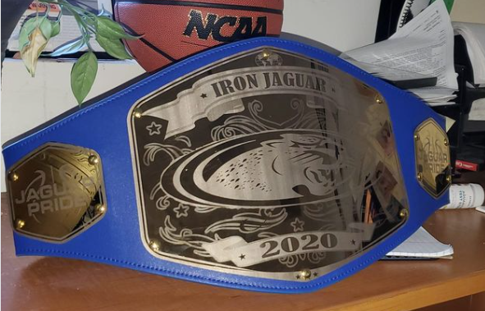

**Playing Time:** During the Winter season, the games we will play will hold much higher value in terms of necessity to win.  Whether it is league play or tournaments.  Although this current team is deep and talented, I suspect that some will eventually be unhappy with who we start and the playing time involved.  This is especially true when we play short games like we did this past weekend.  The high school regulation games held at home are much easier to give everyone a good amount of PT.  Simply put...we will put the team on the floor that my staff and I believe gives us the best opportunity to win (assuming those players have a qualifying participation rate).

As a general rule, I will not discuss playing time with parents.  I have instructed my assistant coaches not to entertain "sidebar" discussions of playing time nor will we discuss game strategy.  What will we discuss?  We will be happy to discuss the development of your son and what we think he needs to focus on to get better (and of course HS recruitment).  If you wish to discuss that, please let us know and we will be happy to carve out some time to meet with you as a staff.

**Spectator Behavior:** I don't anticipate any issues and the fan behavior in the stands through 7 games has been perfect.  Certainly, if anyone was going to go after a referee, it would have been seen this past weekend LOL.  But be reminded that we do not tolerate any behavior that might tarnish the reputation of the church or school.  Also...any fan that gets ejected from a CYO sanctioned event, costs us $500...so there's that.  I would also like to ask kindly that the "coaching" from the parents be kept to a minimum.  I know it is difficult and everyone wants their kids to do specific things...but **be spectators**.  If at any time we feel that the "coaching" from the bleachers is causing a conflict, we will sit players.

**In Summary:**  I recognize that playing in our program is not always for everyone.  We have a long list of players that leave us each season for one reason or another.  Usually, it is a combination of PT concerns and positional concerns.  Sometimes it is due to overcommitments to other teams and other extracurriculars. Regardless... We never take it personally if a parent feels the need to leave the team.  However, we really would like to find these issues out **BEFORE** the deadline to add other players.  For example, last year we had 3 players quit after December 1st.  That was three positions that I could have used for younger guys like Khy and Puffy to play up.  If you are wavering now or your son is not happy on the team...my experience and gut instinct is that it might not change after another month of games and practices.

For those that choose to stay the course and continue with the Jaguar Family....we appreciate you and promise to do our best as a coaching staff to make it a memorable and productive season.

Sincerely,

Coach Sego

Coach Tyler

Coach Carlos